Megan Manata 1/18/17

FEWD

Final Project Proposal

The ultimate goal for my project would be to give a serious face-lift for our family pizzeria. The concept was opened in the mid-1990s. Our web presence is still stuck in a time warp.. Sadly, the [website](http://www.famousamadeus.com/ContactUs.tpl?cart=148470515331539810) went live in 2008, yet is outdated even by 2008 standards. Serious changes need to be had in order to bring this website into the future. I will be essentially building everything on the website, save for (hopefully) professional photos we have lying around. The tone of voice I am trying to create for the brand is an outspoken “knows what they want” New Yorker. Everything on the current website can be discarded including the outdated logo.

In terms of design, I’m still sort of on the fence. I’m looking for a fun site that is “serious and cool” but also has a loud personality. For example, we are currently using these icons:

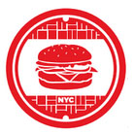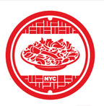

But we had these mockups made a few years ago, and this is more along the lines of the personality I’d want for us to display:

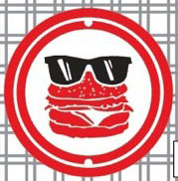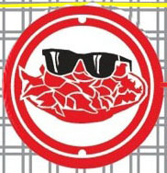

I want the website to be funny, entertaining, a little sarcastic, but professional.

Looking around I kind of had a hard time finding what it is I wanted. On awwwards, there’s an outdated thumbnail from the Mellow Mushroom (a pizzeria located primarily in the South) that I like:

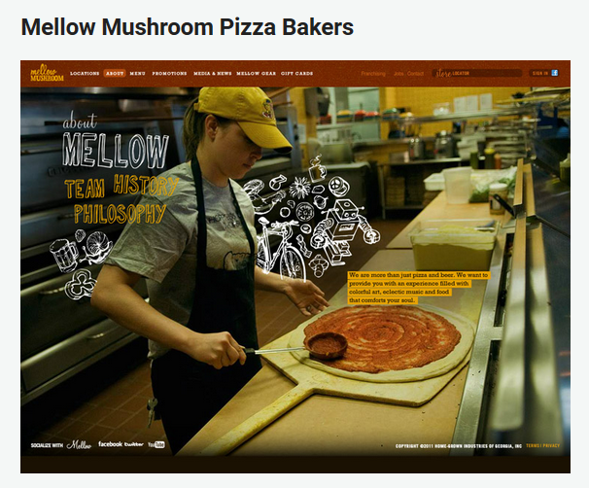

I’d just link you to the whole page, but since this screenshot, they’ve updated to a boring website.

Other designs I liked:

1. [Wokitokee](http://www.wokitokee.com/) – I love how fun this website is, however I do understand the limitations of my skills to pull this off. Also, I’m not sure this design could accommodate the large menu we have.
2. [Caravan](http://www.caravanrestaurants.co.uk/exmouth-market.html) – This is what I consider to be the baseline of a well-designed site. I was hoping for something more interesting than this, but this is fine.
3. [Marie Catribs](http://mariecatribs.com/) – While this is not the style I want, I do like all of the little extra elements that pop up on mouse over. The little arrows and the ‘’’’ symbols are neat.
4. [Huxtaburger](http://www.huxtaburger.com.au/) – I like the simplicity of it, but is it too simple? I think we need food photos.
5. [Yogurt Labs](http://www.yogurtlabs.com/) – Really love how when a user scrolls down, images appear explaining how their product works. Would love to figure out how to incorporate this if it makes sense design-wise.
6. [Blue Ribbon Fried Chicken](http://blueribbonfriedchicken.com/) – Great design. They have really awesome photos, which we’re sort of lacking.
7. [Salut Kitchen Bar](http://www.salutkitchenbar.com/) – Basic “well designed” restaurant website. The best thing is the menu. I like the organization of the different item types plus the layout. We don’t have a photo of every object, and won’t have it before the redesign would go live.

I’d love to hear your opinions on how to consolidate these ideas and move forward with a design. I don’t have very much design experience, so any help would be great.